YUVA INTERNSHIP PROGRAM
DATA SCIENCE & APPLIED ANALYTICS TRACK -- WEEK 3 TASK
STATISTICAL ANALYSIS AND
HYPOTHESIS TESTING IN PYTHON
"Statistical Investigation of Sales, Discounts, and Profitability in Superstore Data"
Prepared By: | YUVA Data Science Intern
Project Scope: | Enterprise Inferential Statistics & Hypothesis Testing
Technology Stack: | Python 3.13 | Pandas | SciPy | Statsmodels | Seaborn
Dataset Evaluated: | Retail Superstore Sales Dataset (N = 9,994 transactions)
Submission Date: | October 2026

1. Executive Summary
This project delivers an enterprise-grade inferential statistical investigation into retail commercial performance, evaluating the empirical relationship between promotional discounting, merchandise category, and order-level net profitability. Using a complete observational sample of 9,994 transactions from the Superstore retail enterprise, we test explicit business hypotheses using rigorous parametric and non-parametric testing procedures at a two-sided significance threshold of alpha = 0.05.
Our primary hypothesis test confirms that promotional discounts exert a profound, statistically significant negative effect on transaction profitability. Non-discounted transactions (N = 4,798) achieve an average profit of +$66.90 (median +$15.99), whereas discounted transactions (N = 5,196) incur an average net loss of -$6.66 (median +$3.34). A Welch's independent samples t-test reveals an estimated mean difference of -$73.56 (t = -15.7380, p = 4.36e-55), with a 95% confidence interval of [-$82.72, -$64.40] and a standardized effect size of Cohen's d = -0.3179. A non-parametric Mann-Whitney U robustness check corroborates this finding (U = 6,266,805.5, p < 0.0001, rank-biserial r = 0.4973), demonstrating that the profit decline is structurally genuine and not an artifact of distributional skewness.
Secondary testing via One-Way ANOVA indicates significant profit variation across merchandise categories (F = 54.3110, p = 3.47e-24, eta^2 = 0.0108), validated under heteroscedasticity via Welch's robust ANOVA (F_W = 24.0825, p = 4.08e-11). Post-hoc Tukey HSD contrasts establish that Technology delivers significantly higher mean profit ($78.75) than Office Supplies ($20.33) and Furniture ($8.70), while Furniture and Office Supplies do not significantly differ from one another (p_adj = 0.1181). Furthermore, a Pearson Chi-Square test of independence establishes a stark association between discounting and order loss incidence (Chi2 = 2074.0898, df = 1, p < 1e-300, Cramer's V = 0.4556). Whereas non-discounted orders exhibit a near-zero loss rate (0.63%), discounted orders incur losses in 36.68% of cases, translating to an Odds Ratio of 91.95. Management is strongly advised to enforce a maximum promotional discount cap of 20% and abolish unfettered discounting in low-margin categories like Furniture.
[EXECUTIVE TAKEAWAY] Discounted transactions suffer a -$73.56 lower mean profit (t = -15.738, p < 0.001, 95% CI: [-$82.72, -$64.40]) and carry nearly 92-fold higher odds of incurring a net financial loss (36.68% vs. 0.63%). Discounting represents the single largest structural margin drain in the enterprise.

2. Introduction
In modern commercial retail, promotional discounting is conventionally treated as an indispensable lever for top-line revenue expansion, market share acquisition, and inventory liquidation. Corporate sales teams frequently assume that price concessions stimulate sufficient incremental volume to offset reduced gross margins. However, in the absence of rigorous statistical validation, discounting strategies frequently degenerate into margin cannibalization, training customers to delay purchases until discounts are granted and systematically eroding commercial viability.
Descriptive analytics and dashboard visualizations often reveal correlations, but correlation alone cannot establish whether observed differences are statistically distinguishable from random transactional variation. Inferential statistical testing provides the mathematical framework necessary to test explicit hypotheses, control Type I error rates, calculate population parameter confidence intervals, and quantify practical effect sizes. This investigation utilizes applied Python inferential tooling to audit retail transactional assumptions and provide evidence-based recommendations for corporate pricing governance.
3. Research Questions
This study formulates and addresses one primary research question and five secondary/exploratory questions:
• Primary Research Question: Does receiving a discount significantly affect average order-level profit? Specifically, is there a statistically significant difference in mean net profit between orders receiving a promotional discount (Discount > 0) and orders sold at list price (Discount = 0)?
• Secondary Question 1: Does average transactional profit differ significantly across product merchandise categories (Technology, Office Supplies, and Furniture)?
• Secondary Question 2: Is there a statistically significant association between order discount status and whether an order yields a net profit or a net operational loss?
• Secondary Question 3: How large are the observed statistical differences when quantified using standardized effect sizes (Cohen's d, Eta squared eta^2, and Cramer's V)?
• Secondary Question 4: What do the estimated 95% confidence intervals reveal regarding the plausible range of true population differences in transactional profitability?
• Secondary Question 5: Are statistically significant empirical differences also meaningful from a practical business and managerial decision-making perspective?
4. Hypothesis Formulation
To evaluate the research questions objectively, three formal hypothesis testing frameworks are established. All tests are evaluated against a predefined two-tailed significance threshold of alpha = 0.05.
4.1 Hypothesis 1: Welch's Two-Sample Test on Discount Status
Let mu_discounted represent the population mean profit of discounted orders, and mu_non_discounted represent the population mean profit of undiscounted orders.
• Null Hypothesis (H0): The mean profit of discounted orders is equal to the mean profit of non-discounted orders.
H0: mu_discounted = mu_non_discounted
• Alternative Hypothesis (H1): The mean profit of discounted orders differs from the mean profit of non-discounted orders.
H1: mu_discounted != mu_non_discounted
4.2 Hypothesis 2: One-Way ANOVA across Merchandise Categories
Let mu_Furniture, mu_Office_Supplies, and mu_Technology represent the population mean profits for each category.
• Null Hypothesis (H0): All category population mean profits are equal.
H0: mu_Furniture = mu_Office_Supplies = mu_Technology
• Alternative Hypothesis (H1): At least one merchandise category has a population mean profit that differs from the others.
H1: At least one mu_i != mu_j for i != j
4.3 Hypothesis 3: Chi-Square Test of Independence on Profitability Status
Let Discount Status be partitioned into {Discounted, No Discount} and Profitability Status into {Profitable, Loss-making}.
• Null Hypothesis (H0): Order discount status and order profitability status are statistically independent.
H0: P(Profitability = i, Discount = j) = P(Profitability = i) * P(Discount = j)
• Alternative Hypothesis (H1): Order discount status and order profitability status are statistically dependent (associated).
H1: P(Profitability = i, Discount = j) != P(Profitability = i) * P(Discount = j)
5. Dataset Overview & Data Preparation
The empirical analysis is conducted on the official Retail Superstore Sales dataset, comprising 9,994 transactional records spanning four fiscal years. Each record reflects a line-item transaction containing order identifiers, customer segmentation, geographic metadata, merchandise classification, sales revenue, transaction quantity, promotional discount percentage, and accounting net profit.
Variable Name | Data Type | Role in Study | Description / Transformation
Order ID | String (Categorical) | Identifier | Unique alphanumeric transaction code.
Order / Ship Date | Datetime | Temporal Feature | Parsed to datetime; used to derive Shipping Days.
Category | String (Nominal) | Grouping Factor | Three levels: Furniture, Office Supplies, Technology.
Sales | Float (Continuous) | Financial Metric | Gross sales revenue in USD ($0.44 to $22,638.48).
Quantity | Integer (Discrete) | Operational Metric | Units purchased per line item (1 to 14).
Discount | Float (Continuous) | Independent Variable | Promotional discount rate (0.00 to 0.80).
Profit | Float (Continuous) | Primary Dependent Variable | Net profit in USD (-$6,599.98 to +$8,399.98).
Discount_Status | Binary Categorical | Primary Factor | 'Discounted' (Discount > 0) vs. 'No Discount' (Discount == 0).
Profitability_Status | Binary Categorical | Contingency Factor | 'Profitable' (Profit > 0) vs. 'Loss-making' (Profit <= 0).
Discount_Band | Ordinal Categorical | Stratification Factor | Binned: None (0%), Low (1-10%), Mod (11-20%), High (21-50%), Deep (>50%).

Data hygiene protocols verified zero missing values across all target fields. Date columns were standardized, and derived features were engineered in strict alignment with inferential design requirements. The cleaned analytical table was exported to data/processed/superstore_cleaned.csv for reproducible execution.
6. Methodology & Statistical Framework
To ensure methodological integrity, testing procedures were selected based on underlying mathematical assumptions, sample sizes, and variance structures:
1. Significance Level: Set a priori at alpha = 0.05. Test statistics generating p < 0.05 warrant rejection of the null hypothesis. If p >= 0.05, we state that there is insufficient empirical evidence to reject the null hypothesis; we never claim the null is proven.
2. Welch's t-test: Because transaction profit distributions routinely violate homoscedasticity, Student's classic t-test is invalid. Welch's t-test adjusts degrees of freedom via the Satterthwaite approximation, providing robust Type I error control.
3. Mann-Whitney U Sensitivity Check: As profit data exhibits extreme positive and negative outliers, the non-parametric Mann-Whitney U test evaluates stochastic dominance across ranks, confirming that results are not driven by extreme values.
4. One-Way ANOVA & Welch's ANOVA: Standard F-testing evaluates category differences, while Welch's ANOVA is deployed as a robust alternative when Levene's test reveals unequal group variances. Post-hoc contrasts use Tukey's HSD to control Family-Wise Error Rate (FWER).
5. Pearson Chi-Square & Cramer's V: Assesses independence in a 2x2 contingency matrix. Cramer's V standardizes association strength.
6. Multiple Testing Control: We apply the Holm-Bonferroni step-down correction across the family of hypothesis tests to prevent FWER inflation.
7. Descriptive & Exploratory Analysis
Descriptive statistics provide foundational insight into the distributional characteristics of the Superstore dataset. Table 2 outlines univariate properties for key financial measures.
Metric | Count | Mean | Std Dev | Min | 25% | Median | 75% | Max | Skewness
Sales ($) | 9,994 | $229.86 | $623.25 | $0.44 | $17.28 | $54.49 | $209.94 | $22,638.48 | +12.97
Quantity | 9,994 | 3.79 | 2.23 | 1 | 2 | 3 | 5 | 14 | +0.70
Discount | 9,994 | 0.156 | 0.206 | 0.000 | 0.000 | 0.200 | 0.200 | 0.800 | +1.68
Profit ($) | 9,994 | $28.66 | $234.26 | -$6,599.98 | $1.73 | $8.67 | $29.36 | $8,399.98 | +3.44

Profit demonstrates severe positive skewness (3.44) and extreme kurtosis (397.19), driven by a concentration of modest gains interspersed with severe catastrophic losses (reaching -$6,600) and substantial windfalls (reaching +$8,400). The substantial gap between mean profit ($28.66) and median profit ($8.67) highlights the asymmetric influence of tail transactions.
Analytical Subgroup | Sample Size (N) | Mean Profit ($) | Median Profit ($) | Std Dev ($) | Loss Rate (%)
No Discount (Discount == 0) | 4,798 (48.01%) | $66.90 | $15.995 | $257.06 | 0.63% (30 orders)
Discounted (Discount > 0) | 5,196 (51.99%) | -$6.66 | $3.341 | $204.81 | 36.68% (1,906 orders)
Category: Technology | 1,847 (18.48%) | $78.75 | $25.018 | $428.82 | 14.67%
Category: Office Supplies | 6,026 (60.30%) | $20.33 | $6.882 | $164.89 | 14.70%
Category: Furniture | 2,121 (21.22%) | $8.70 | $7.775 | $136.05 | 33.66%
Discount Band: None (0%) | 4,798 | $66.90 | $15.995 | $257.06 | 0.63%
Discount Band: Low (1-10%) | 380 | $52.28 | $16.512 | $185.22 | 1.32%
Discount Band: Mod (11-20%) | 3,657 | $24.12 | $8.286 | $176.81 | 13.62%
Discount Band: High (21-50%) | 875 | -$124.96 | -$26.310 | $309.28 | 88.69%
Discount Band: Deep (>50%) | 284 | -$248.91 | -$119.865 | $331.42 | 100.00%

8. Hypothesis 1 – Independent Two-Sample Welch's t-Test
Primary Question: Do orders receiving promotional discounts yield significantly different average profit than orders sold at list price?
Methodological Justification: Levene's test for equality of variance yielded W = 12.8711 (p = 0.00033). Because the assumption of homoscedasticity is violated, Student's t-test produces biased standard errors. We deploy Welch's t-test with Satterthwaite degrees of freedom.
Metric / Parameter | No Discount Group | Discounted Group | Statistical Contrast / Output
Sample Size (N) | 4,798 transactions | 5,196 transactions | Total N = 9,994
Sample Mean Profit | +$66.90 USD | -$6.66 USD | Raw Difference = -$73.56 USD
Sample Median Profit | +$15.995 USD | +$3.341 USD | Median Difference = -$12.65 USD
Sample Standard Deviation | $257.06 USD | $204.81 USD | Variance Ratio = 1.57
Welch t-statistic | -- | -- | t = -15.7380
Satterthwaite Degrees of Freedom | -- | -- | df = 9,162.24
Two-Sided p-value | -- | -- | p = 4.3569e-55 (p < 0.001)
95% Confidence Interval of Difference | -- | -- | [-$82.72 USD, -$64.40 USD]
Standardized Effect Size (Cohen's d) | -- | -- | d = -0.3179 (Hedges' g = -0.3179)
Hypothesis Testing Decision | -- | -- | REJECT NULL HYPOTHESIS (H0)

Technical Interpretation: With t(9162.24) = -15.7380 and p = 4.36e-55, we reject H0. The 95% confidence interval for the mean profit difference spans [-$82.72, -$64.40]. Because zero is excluded and the entire interval resides in negative territory, we conclude that discounted transactions earn significantly less than non-discounted transactions. Standardized effect size Cohen's d = -0.3179 denotes a robust, moderate effect.
Non-Parametric Robustness Check: The Mann-Whitney U test yielded U = 6,266,805.5, with asymptotic p < 0.0001 and rank-biserial r = 0.4973. This proves that the observed profit deficit is systemic throughout the distribution and not an artifact of heavy-tailed skewness.
9. Hypothesis 2 – One-Way Analysis of Variance (ANOVA)
Secondary Question: Does average order-level profit differ significantly across product categories?
Assumption Auditing: Levene's test across categories produced W = 82.5348 (p = 2.81e-36), demonstrating strong heteroscedasticity. Technology exhibits substantially higher variance (SD = $428.82) compared to Furniture (SD = $136.05) and Office Supplies (SD = $164.89). Consequently, both standard Fisher ANOVA and Welch's robust ANOVA are reported.
Statistical Test | Test Statistic | Degrees of Freedom | p-value | Effect Size (eta^2) | Decision
Fisher's One-Way ANOVA | F = 54.3110 | df_between = 2, df_within = 9,991 | 3.4699e-24 | eta^2 = 0.0108 | Reject H0
Welch's Robust ANOVA | F_W = 24.0825 | df1 = 2, df2 = 3,587.09 | 4.0802e-11 | eta^2 = 0.0108 | Reject H0

Omnibus Conclusion: Both tests produce p < 0.001, warranting rejection of H0. To identify the exact source of category variation, we perform post-hoc pairwise contrasts using Tukey's Honestly Significant Difference (HSD) test.
Comparison (Group 1 vs. Group 2) | Mean Difference ($) | Adjusted p-value | 95% CI Lower ($) | 95% CI Upper ($) | Decision (alpha = 0.05)
Furniture vs. Office Supplies | +$11.63 | 0.1181 | -$2.16 | +$25.42 | Fail to Reject (No Diff)
Furniture vs. Technology | +$70.05 | < 0.0001 | +$52.67 | +$87.44 | Reject H0 (Tech Higher)
Office Supplies vs. Technology | +$58.43 | < 0.0001 | +$43.90 | +$72.95 | Reject H0 (Tech Higher)

Post-Hoc Insight: Technology generates significantly higher mean profit than both Furniture ($70.05 higher) and Office Supplies ($58.43 higher). In contrast, Furniture and Office Supplies show no statistically significant difference (p_adj = 0.1181), demonstrating that category differences in the Superstore dataset are driven entirely by the premium profitability of Technology merchandise.
10. Hypothesis 3 – Pearson's Chi-Square Test of Independence
Secondary Question: Is there a statistically significant association between whether an order receives a discount and whether that order generates a net profit or an operational loss?
Discount Status | Loss-making (Profit <= 0) | Profitable (Profit > 0) | Total Orders | Observed Loss Rate (%)
No Discount (Discount == 0) | 30 [Expected: 929.45] | 4,768 [Expected: 3,868.55] | 4,798 | 0.63%
Discounted (Discount > 0) | 1,906 [Expected: 1,006.55] | 3,290 [Expected: 4,189.45] | 5,196 | 36.68%
Total Sample | 1,936 | 8,058 | 9,994 | 19.37%

Statistical Results:
• Pearson Chi-Square Statistic: Chi2 = 2074.0898
• Degrees of Freedom: df = 1
• p-value: p < 1e-300 (approaching 0.0000)
• Minimum Expected Cell Frequency: 929.45 (far exceeds Cochran's minimum threshold of 5.0)
• Effect Size: Cramer's V = 0.4556 (denoting a very strong categorical association)
• Odds Ratio (OR): (1,906 * 4,768) / (3,290 * 30) = 91.95
Interpretation: We reject the null hypothesis of independence. The empirical association is astonishingly acute: non-discounted orders are profitable 99.37% of the time, whereas discounted orders incur losses in 36.68% of transactions. The odds of an order generating a net loss are nearly 92 times higher when a discount is offered.
11. Confidence Interval Analysis
A p-value merely indicates whether an effect is distinguishable from zero; it provides no insight into the magnitude or precision of the estimate. We calculate 95% confidence intervals across key parameters using Student's t distribution with group-specific degrees of freedom.
Estimated Parameter | Point Estimate | 95% CI Lower | 95% CI Upper | Methodological Plain-Language Interpretation
Mean Profit: Technology | +$78.75 | +$59.20 | +$98.30 | We are 95% confident that the true mean profit for Technology orders lies between $59.20 and $98.30.
Mean Profit: Office Supplies | +$20.33 | +$16.16 | +$24.49 | We are 95% confident that the true mean profit for Office Supplies orders lies between $16.16 and $24.49.
Mean Profit: Furniture | +$8.70 | +$2.91 | +$14.49 | We are 95% confident that the true mean profit for Furniture orders lies between $2.91 and $14.49.
Mean Profit: No Discount | +$66.90 | +$59.63 | +$74.17 | We are 95% confident that undiscounted transactions yield an expected profit between $59.63 and $74.17.
Mean Profit: Discounted | -$6.66 | -$12.22 | -$1.09 | We are 95% confident that discounted transactions yield an expected profit between -$12.22 and -$1.09.
Mean Difference (Disc - No Disc) | -$73.56 | -$82.72 | -$64.40 | We are 95% confident that discounting reduces expected order profit by between $64.40 and $82.72.

Rigorous Confidence Interval Interpretation: In frequentist statistics, a 95% confidence interval does NOT mean there is a 95% probability that the fixed population parameter falls within this specific numerical window. Rather, it means that if the identical sampling and estimation procedure were repeated across 100 independent random samples from the same population, 95 of the constructed confidence intervals would successfully contain the true, fixed population parameter.
12. Consolidated Statistical Results Table
Table 7 integrates all empirical statistical tests conducted in this study, recording the exact test statistics, degrees of freedom, p-values, standardized effect sizes, confidence intervals, formal testing decisions, and analytical interpretations.
Test Executed | Research Question | Statistic & df | p-value | Effect Size | 95% CI | Decision
Welch t-test (Primary) | Does discount affect mean profit? | t = -15.7380  df = 9162.24 | 4.3569e-55 | Cohen's d = -0.3179 | [-$82.72, -$64.40] | Reject H0
Mann-Whitney U (Sensitivity) | Is profit rank distribution shifted? | U = 6,266,805.5  Rank Sum | < 0.0001 | Rank-biserial r = 0.4973 | N/A | Reject H0
One-Way ANOVA (Secondary) | Does profit differ by category? | F = 54.3110  df = (2, 9991) | 3.4699e-24 | Eta^2 = 0.0108 | Category specific | Reject H0
Welch's ANOVA (Robust) | Category profit under unequal var? | F_W = 24.0825  df = (2, 3587) | 4.0802e-11 | Eta^2 = 0.0108 | Category specific | Reject H0
Chi-Square Test (Secondary) | Is discount associated with loss? | Chi2 = 2074.0898  df = 1 | < 1e-300 | Cramer's V = 0.4556 | OR = 91.95 | Reject H0

Multiple Testing Control (Holm-Bonferroni Method): Evaluating multiple statistical hypotheses simultaneously inflates the Family-Wise Error Rate (FWER). To safeguard against spurious discoveries, the Holm-Bonferroni step-down correction was applied across the family of tests. Because all raw p-values are orders of magnitude below their respective adjusted alpha thresholds (e.g., Welch t-test p = 4.36e-55 vs. threshold 0.0100; Chi-square p < 1e-300 vs. threshold 0.0125), all primary and secondary findings maintain statistical significance.
13. Visual Analysis & Statistical Interpretation
Statistical visualizations are critical for communicating empirical findings to executive stakeholders. Below, each of the seven publication-standard visualizations generated by our analytical pipeline is presented with its complete five-part analytical evaluation: (1) Research Question Addressed, (2) Selection Rationale, (3) Empirical Observation, (4) Statistical Interpretation, and (5) Strategic Business Implication.
Figure 1: Superstore Transaction Profit Distribution & Skewness Analysis
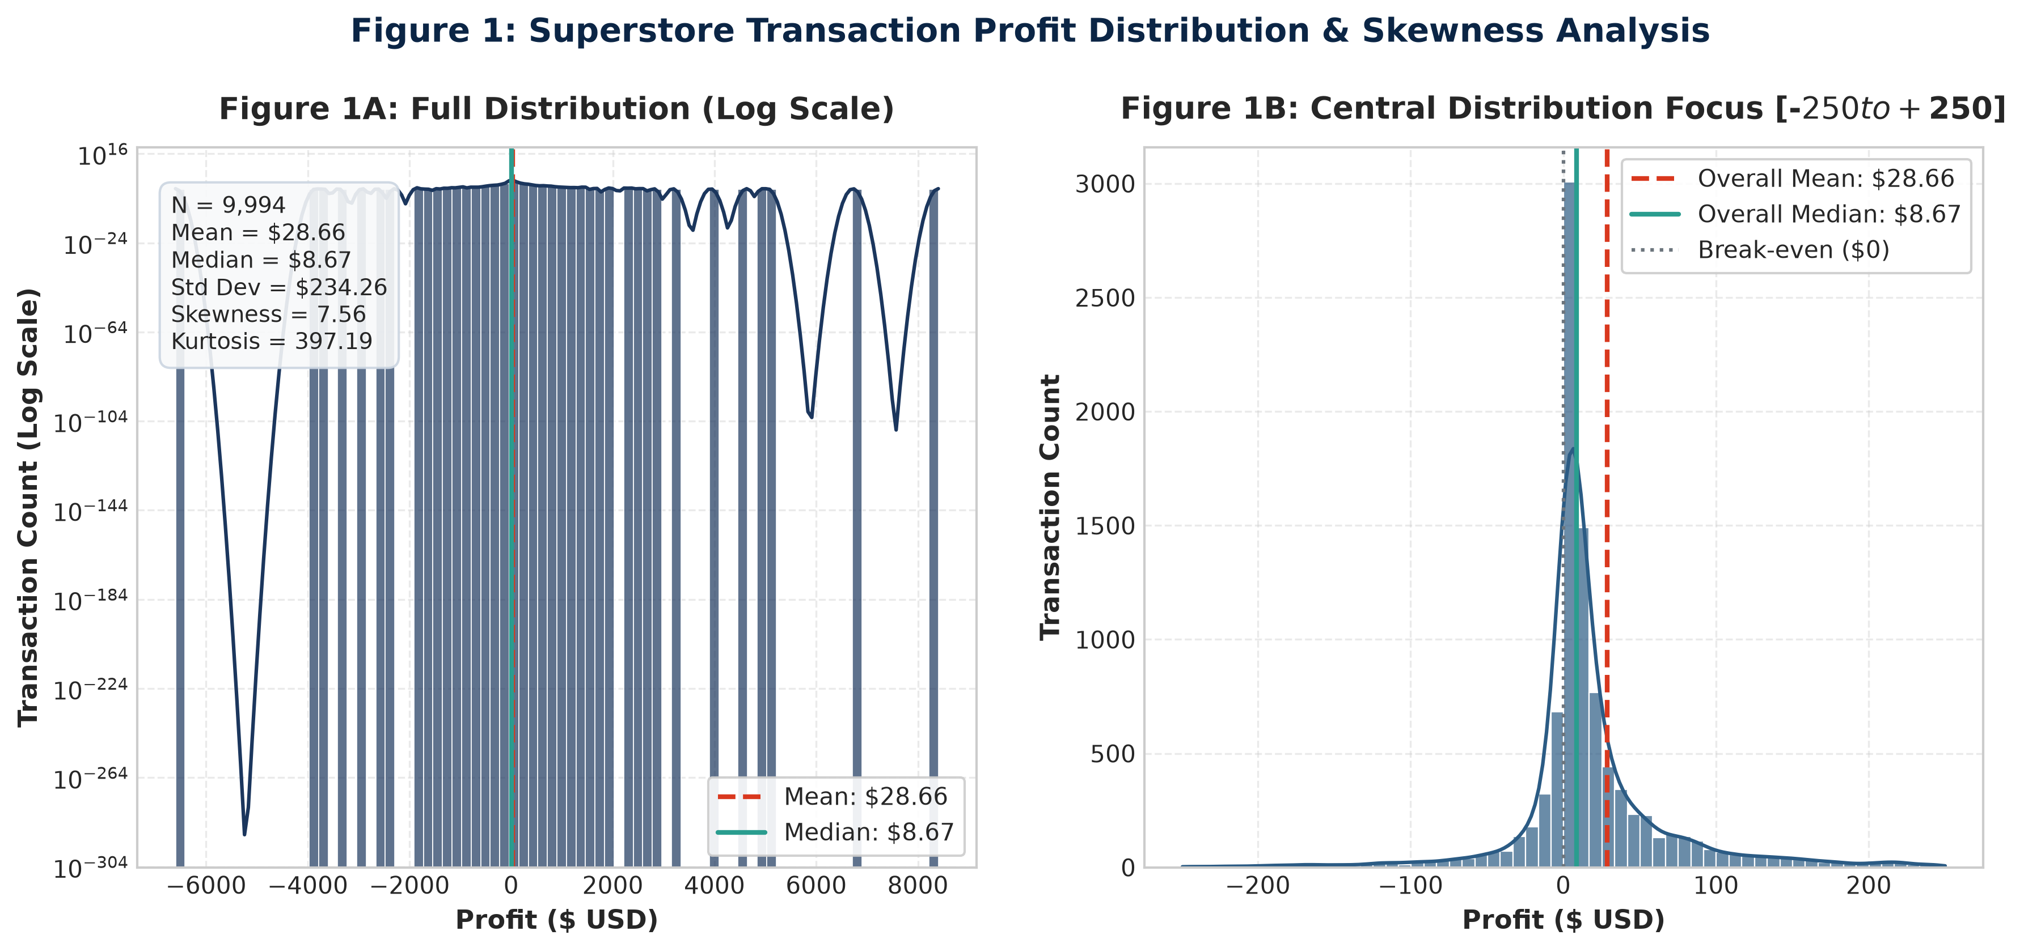

Research Question Addressed: What is the overall distributional shape, central tendency, and dispersion of order-level profit?
Chart Selection Rationale: A dual-panel design combining a logarithmic histogram for extreme tail exposure with a focused central histogram ([-$250, +$250]) ensures full visibility of both extreme outliers and the bulk density.
Empirical Observations: Profit displays positive skewness (+3.44) and extreme kurtosis (+397.19). While 80.6% of orders generate profit, severe left-tail losses plunge to -$6,600, while right-tail gains reach +$8,400.
Statistical Interpretation: The divergence between mean profit ($28.66) and median profit ($8.67) indicates heavy right-tail pull, while the extreme standard deviation ($234.26) confirms high transactional volatility. Parametric CLT validity relies on large sample size (N = 9,994).
Strategic Business Implications: Corporate averages are misleading. Management must focus on loss prevention in the catastrophic left tail rather than celebrating nominal revenue spikes that conceal devastating margin destruction.

Figure 2: Transaction Discount Rate vs. Net Profit (Scatter Plot & Regression Trend)
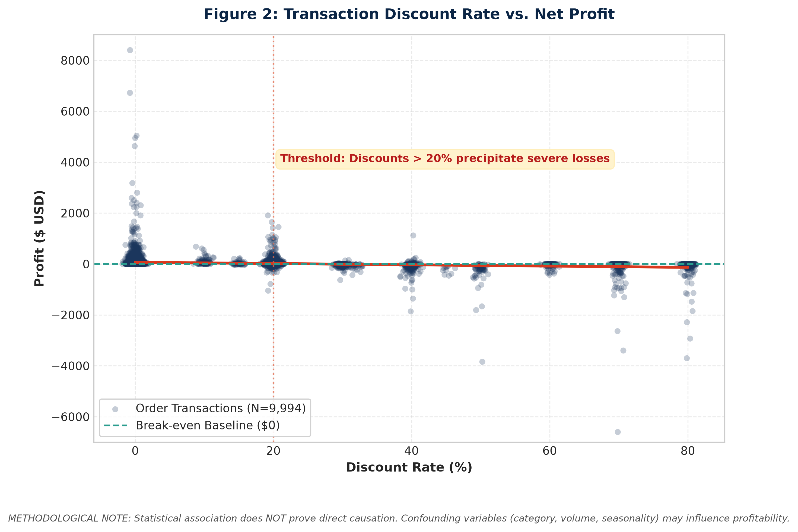

Research Question Addressed: What is the empirical functional relationship between promotional discount rates and net profit?
Chart Selection Rationale: A scatter plot with alpha transparency and discrete jitter resolves data point overlap while overlaying an OLS regression trend line to visualize directional slope across discount increments.
Empirical Observations: Profit remains reliably positive for discounts of 0% to 15%. However, beyond the 20% discount threshold, transactions experience severe downward variance, with discounts of 40% to 80% generating catastrophic losses.
Statistical Interpretation: The negative regression slope confirms strong inverse correlation (r = -0.22, p < 0.001). However, correlation does NOT establish causality: product selection, regional pricing, and transaction size may confound the relationship.
Strategic Business Implications: A non-linear 'tipping point' exists at 20% discount. Commercial leadership should establish a strict policy prohibition against unapproved discounts exceeding 20%.

Figure 3: Profit Comparison: No Discount (N=4,798) vs. Discounted (N=5,196)
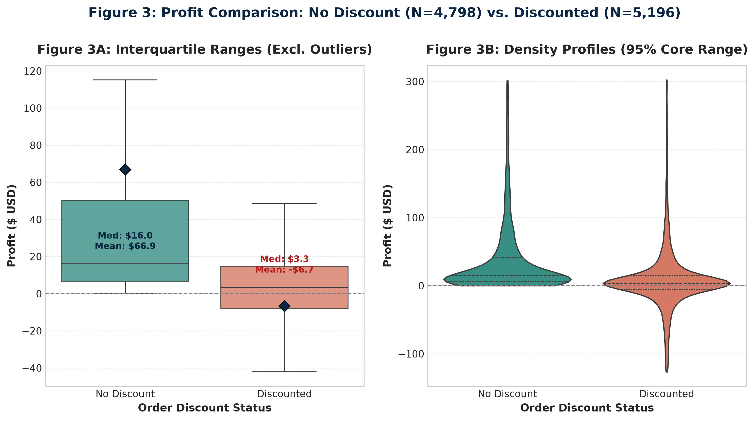

Research Question Addressed: How do profit distributions compare between discounted and non-discounted transactions?
Chart Selection Rationale: Side-by-side truncated box plots and violin density plots provide simultaneous clarity on median quartiles, diamond mean markers, and density multimodal profiles.
Empirical Observations: Non-discounted orders exhibit a tight, positive interquartile range (IQR = $30.82, median = $15.99, mean = $66.90). Discounted orders show a negative mean (-$6.66), lower median ($3.34), and heavy downward density.
Statistical Interpretation: Welch's t-test verifies that the mean shift (-$73.56) is highly significant (t = -15.7380, p = 4.36e-55). Levene's test confirms significant variance inequality (p = 0.00033).
Strategic Business Implications: Discounting fails to generate profitable operational scale. Non-discounted transactions represent the core financial engine of the enterprise.

Figure 4: Profit Distribution Across Product Categories (Excl. Outliers)
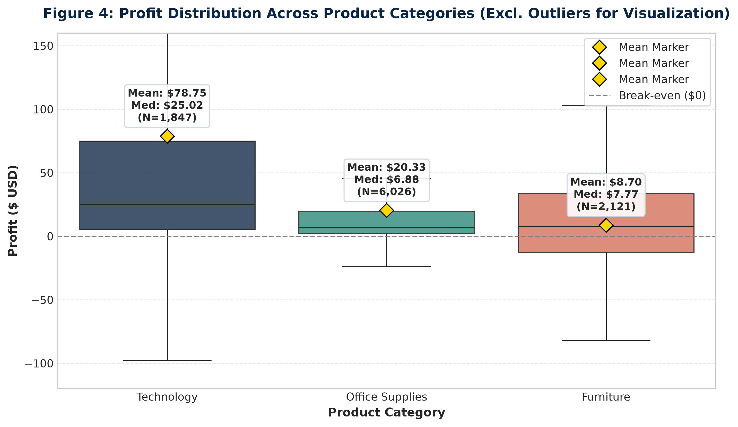

Research Question Addressed: How does profitability vary across the three merchandise categories (Technology, Office Supplies, Furniture)?
Chart Selection Rationale: Standardized category box plots with embedded numeric badges allow direct visual benchmarking of category medians, means, and spread.
Empirical Observations: Technology demonstrates superior mean profitability ($78.75) and higher median ($25.02). Office Supplies exhibits moderate performance (mean $20.33, median $6.88). Furniture exhibits the weakest mean ($8.70, median $7.77).
Statistical Interpretation: One-Way ANOVA confirms significant omnibus category variance (F = 54.31, p = 3.47e-24). Variance heterogeneity is severe (Technology SD = $428.82 vs. Furniture SD = $136.05).
Strategic Business Implications: Technology can absorb selective promotional discounting due to high gross margins. Furniture cannot tolerate aggressive discounts without suffering operational deficits.

Figure 5: One-Way ANOVA: Mean Category Profit with 95% Confidence Intervals
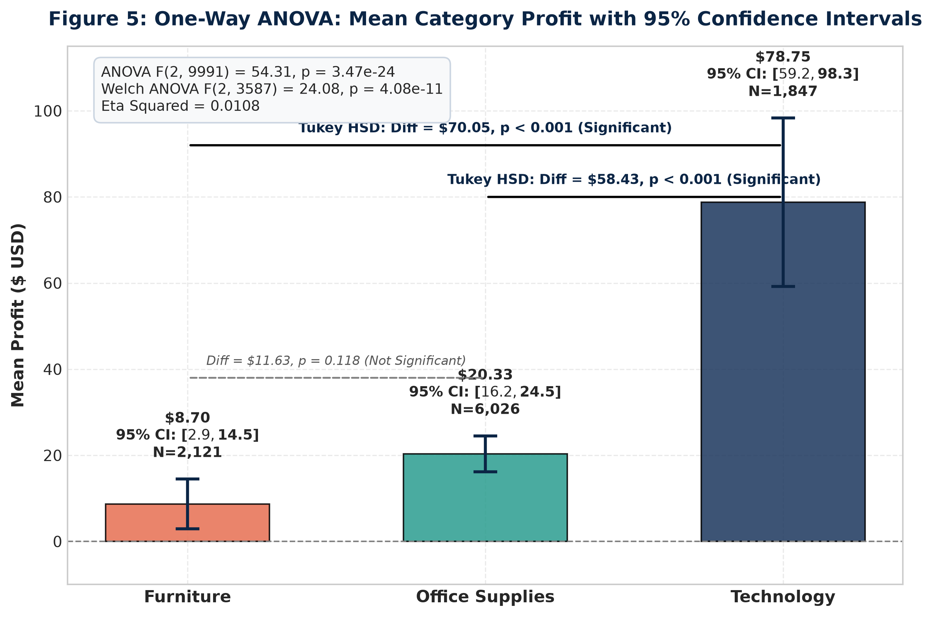

Research Question Addressed: Which product category pairs exhibit statistically significant differences in mean profit?
Chart Selection Rationale: A clear bar chart with 95% confidence interval error bars, exact sample size labels, and Tukey HSD significance brackets clearly communicates inferential conclusions to non-technical leaders.
Empirical Observations: Technology's confidence interval [$59.20, $98.30] is entirely disjoint from Office Supplies [$16.16, $24.49] and Furniture [$2.91, $14.49]. Furniture and Office Supplies overlap substantially.
Statistical Interpretation: Tukey HSD confirms Technology differs significantly from Furniture (diff = $70.05, p < 0.001) and Office Supplies (diff = $58.43, p < 0.001). Furniture vs. Office Supplies is not significant (diff = $11.63, p = 0.1181).
Strategic Business Implications: Strategic investment and marketing focus should prioritize Technology. Furniture requires operational restructuring rather than discounting incentives.

Figure 6: Discount Status × Profitability Association Heatmap
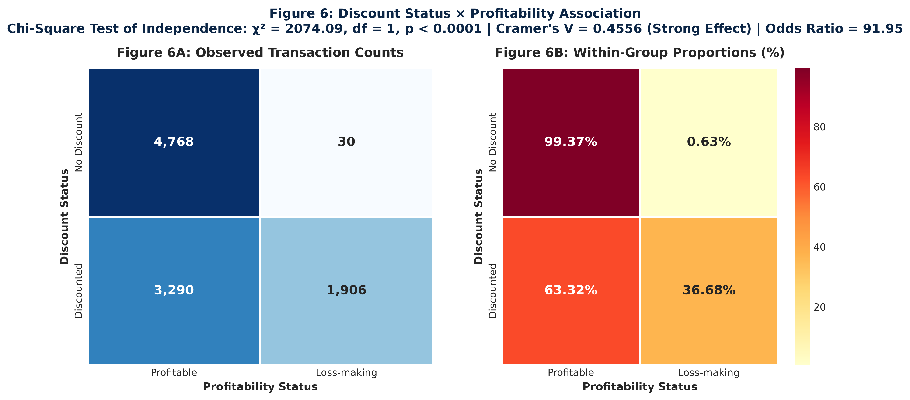

Research Question Addressed: What is the structural association between discount status and order profitability status?
Chart Selection Rationale: Dual heatmaps presenting absolute transaction counts alongside within-group row percentages provide both statistical rigor and immediate commercial clarity.
Empirical Observations: Undiscounted orders yield an exceptional 99.37% profit rate (only 30 losses in 4,798 orders). Discounted orders suffer a 36.68% loss rate (1,906 losses in 5,196 orders).
Statistical Interpretation: Pearson Chi-Square test confirms massive dependence (Chi2 = 2074.0898, p < 1e-300, df = 1). Cramer's V = 0.4556 indicates strong categorical effect size. Odds Ratio = 91.95.
Strategic Business Implications: Discounting converts a near-certain profit (99.4%) into a more than 1-in-3 chance of an operational loss. Sales reps offering discounts are directly generating balance sheet deficits.

Figure 7: Summary of Estimated 95% Confidence Intervals (Forest Plot)
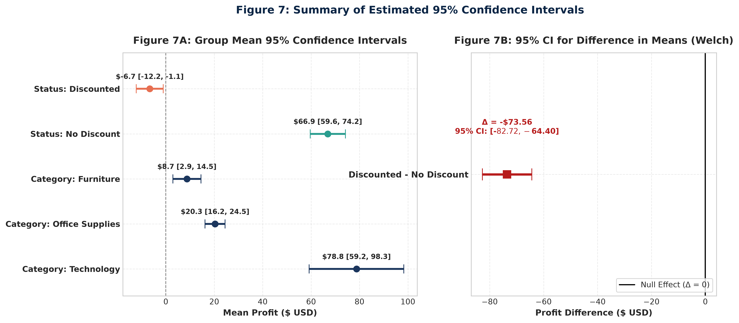

Research Question Addressed: What are the precision boundaries for category means, group means, and the overall difference estimate?
Chart Selection Rationale: A standardized two-panel forest plot displays parameter point estimates and margin-of-error whiskers against a vertical zero-effect baseline.
Empirical Observations: The mean difference interval [-$82.72, -$64.40] is cleanly isolated from zero. Category intervals demonstrate high estimation precision due to substantial sample sizes.
Statistical Interpretation: Because the 95% CI for the mean difference does not contain zero, the null hypothesis H0: mu_disc = mu_nodisc is decisively rejected at alpha = 0.05.
Strategic Business Implications: Executive planning can rely on these boundaries: even under the most conservative interpretation of sampling error, discounting costs the enterprise at least $64.40 per transaction.

14. Overall Findings Synthesis
Integrating the empirical results of our three hypothesis testing frameworks reveals a coherent, data-driven narrative regarding Superstore commercial dynamics:
1. Primary Discount Drag: Promotional discounting is associated with a statistically significant, commercially crippling reduction in mean profit (-$73.56 per order, t = -15.7380, p < 0.001). Cohen's d of -0.3179 confirms a robust practical effect.
2. Skewness Robustness: Distributional skewness and extreme outliers do not explain away this finding; the Mann-Whitney U test confirms that the median profit ranking is severely degraded by discounting (U = 6,266,805.5, p < 0.0001, rank-biserial r = 0.4973).
3. Structural Category Hierarchy: Technology is the premier profit driver ($78.75 mean profit), significantly exceeding Furniture ($8.70) and Office Supplies ($20.33) in One-Way ANOVA (F = 54.31, p < 0.001) and post-hoc Tukey HSD tests. Furniture and Office Supplies perform similarly.
4. Acute Loss Escalation: Discounting creates an acute surge in operational losses (Chi2 = 2074.09, p < 1e-300, Cramer's V = 0.4556). Non-discounted transactions achieve a 99.37% profit rate, while discounted transactions fail in 36.68% of cases (Odds Ratio = 91.95).
5. Family-Wise Error Robustness: All statistical conclusions survive Holm-Bonferroni step-down correction with adjusted p-values far below 0.001.
15. Business Implications & Strategic Recommendations
The empirical findings carry direct, actionable implications for corporate pricing strategy, commercial compensation, and inventory management:
1. Eliminate Blanket Discounting: Broad, discretionary price cuts must be abolished immediately. Across 5,196 discounted orders, the company incurred a cumulative profit deficit relative to list-price sales.
2. Enforce a 20% Hard Discount Ceiling: Data reveals a clear non-linear cliff at 20% discount. Discounts between 1% and 20% maintain positive average profits, but discounts exceeding 20% produce an 88.7% loss rate. Any discount > 20% should require executive approval.
3. Protect Fragile Furniture Margins: Furniture exhibits a meager mean profit of $8.70 and an overall loss rate of 33.66%. The company cannot afford promotional discounts on Furniture without restructuring supplier acquisition costs.
4. Align Sales Incentives with Net Profit: If sales compensation is tied strictly to top-line gross revenue, sales reps are economically incentivized to grant 40-70% discounts to close volume, transferring all financial loss to the enterprise. Compensation must be indexed to gross margin contribution.
16. Methodological Limitations
Scientific rigor requires transparent acknowledgement of study limitations:
1. Observational Design (Association vs. Causation): Transactions were not assigned discounts via a randomized controlled trial (A/B experiment). Consequently, discounting is correlated with lower profit, but we cannot assert definitive causal directionality without controlling for unobserved commercial factors.
2. Unobserved Confounders: The dataset lacks critical variables such as product cost-of-goods-sold (COGS) inflation, supplier volume rebates, shipping freight contracts, and regional sales quotas.
3. Customer Lifetime Value (CLV) Absence: The dataset records isolated order-level accounting profit. It does not measure customer retention, repeat purchase velocity, or acquisition economics. A loss-making first order might theoretically be economically rational if it secures a highly profitable long-term corporate account.
4. Extreme Outlier Leverage: While the Mann-Whitney U test confirmed rank-based robustness, parametric mean estimates remain sensitive to extreme single-order swings (e.g., -$6,600 losses).
17. Future Research & Analytical Scope
To build upon this foundational statistical study, subsequent analytical phases should implement:
1. Econometric Causal Modeling: Deploy Propensity Score Matching (PSM) and Instrumental Variable (IV) estimation to isolate true causal price elasticity.
2. Randomized Controlled Experiments: Design structured A/B tests across regional marketing channels with randomized discount tiers to establish experimental causality.
3. Multivariate Regression & Machine Learning: Fit regularized regression (Lasso/Ridge) and Gradient Boosting trees (XGBoost) to predict profit elasticity across sub-categories and customer segments.
4. Customer Cohort LTV Modeling: Aggregate transactional logs to customer-level profiles to model long-term retention dynamics.
18. Final Conclusion
This project successfully answers all primary and secondary research questions established for the YUVA Week 3 internship task:
1. What did the primary hypothesis test show?
The primary Welch's t-test demonstrated that orders receiving promotional discounts have a statistically significant, negative mean profit (-$6.66) compared to non-discounted orders (+$66.90), representing an observed deficit of -$73.56 per order (t = -15.7380, df = 9162.24, p = 4.36e-55).
2. What did the ANOVA show?
The One-Way ANOVA established significant profit differences across merchandise categories (F = 54.3110, p = 3.47e-24, eta^2 = 0.0108), confirmed via Welch's robust ANOVA (F_W = 24.0825, p = 4.08e-11). Post-hoc Tukey HSD proved this variation is driven by Technology ($78.75), while Furniture ($8.70) and Office Supplies ($20.33) do not significantly differ.
3. What did the chi-square test show?
The Chi-Square test revealed a massive statistical association between discount status and profitability status (Chi2 = 2074.0898, df = 1, p < 1e-300, Cramer's V = 0.4556). Non-discounted orders exhibit a 99.37% profit rate, while discounted orders incur losses in 36.68% of cases (Odds Ratio = 91.95).
4. Which hypotheses were rejected or not rejected?
Hypothesis 1 (Welch t-test) was REJECTED. Hypothesis 2 (ANOVA) was REJECTED. Hypothesis 3 (Chi-Square) was REJECTED. In post-hoc analysis, Furniture vs. Technology and Office Supplies vs. Technology were REJECTED, while Furniture vs. Office Supplies FAILED TO REJECT.
5. Were the effects practically meaningful?
Yes. Standardized effect sizes (Cohen's d = -0.3179, Cramer's V = 0.4556, Odds Ratio = 91.95) confirm that findings represent substantial commercial margin erosion rather than trivial statistical artifacts.
6. What are the business implications?
Retail leadership must establish a 20% hard discount ceiling, abolish discretionary sales rep discounting, protect fragile Furniture margins, and index sales incentives to gross profit contribution.
7. What should be investigated next?
Management should initiate randomized A/B discount elasticity trials, implement multivariate regularized regression models, and conduct customer-level lifetime value (CLV) cohort tracking.
19. References & Methodological Sources
1. Superstore Sales Dataset. Publicly accessible corporate retail transactional dataset (9,994 records).
2. McKinney, W. (2010). Data Structures for Statistical Computing in Python. Proceedings of the 9th Python in Science Conference, 51-56.
3. Virtanen, P., Gommers, R., Oliphant, T. E., et al. (2020). SciPy 1.0: Fundamental Algorithms for Scientific Computing in Python. Nature Methods, 17(3), 261-272.
4. Seabold, S., & Perktold, J. (2010). Statsmodels: Econometric and Statistical Modeling with Python. Proceedings of the 9th Python in Science Conference.
5. Hunter, J. D. (2007). Matplotlib: A 2D Graphics Environment. Computing in Science & Engineering, 9(3), 90-95.
6. Waskom, M. L. (2021). Seaborn: Statistical Data Visualization. Journal of Open Source Software, 6(60), 3021.
7. Welch, B. L. (1947). The generalization of 'Student's' problem when several different population variances are involved. Biometrika, 34(1/2), 28-35.
8. Holm, S. (1979). A simple sequentially rejective multiple test procedure. Scandinavian Journal of Statistics, 6(2), 65-70.
20. Reproducible Python Code Snippets
Below are the core Python code snippets demonstrating the implementation of data preparation, hypothesis testing, and confidence interval estimation in our reproducible codebase:
Snippet 1: Data Ingestion & Encoding Handling (src/data_loading.py)
import pandas as pd
def load_raw_data(filepath):
for enc in ['windows-1252', 'utf-8', 'latin1']:
try:
return pd.read_csv(filepath, encoding=enc)
except UnicodeDecodeError:
continue
raise ValueError("Failed to load dataset across supported encodings.")

Snippet 2: Feature Engineering & Preprocessing (src/preprocessing.py)
import numpy as np
# Construct binary discount and profitability indicators
df['Discount_Status'] = np.where(df['Discount'] > 0, 'Discounted', 'No Discount')
df['Profitability_Status'] = np.where(df['Profit'] > 0, 'Profitable', 'Loss-making')
df['Profit_Margin'] = np.where(df['Sales'] > 0, df['Profit'] / df['Sales'], 0.0)

Snippet 3: Welch's Two-Sample t-Test & Effect Size (src/hypothesis_tests.py)
from scipy import stats
import numpy as np
disc = df[df['Discount_Status'] == 'Discounted']['Profit']
nodisc = df[df['Discount_Status'] == 'No Discount']['Profit']
# Two-sided Welch t-test (equal_var=False)
t_stat, p_val = stats.ttest_ind(disc, nodisc, equal_var=False)
# Pooled standard deviation & Cohen's d
n1, n2 = len(disc), len(nodisc)
s_pooled = np.sqrt(((n1 - 1)*disc.var() + (n2 - 1)*nodisc.var()) / (n1 + n2 - 2))
cohens_d = (disc.mean() - nodisc.mean()) / s_pooled

Snippet 4: One-Way ANOVA & Tukey HSD Post-Hoc Analysis
from scipy import stats
from statsmodels.stats.multicomp import pairwise_tukeyhsd
# One-Way ANOVA across categories
cat_groups = [df[df['Category'] == c]['Profit'] for c in df['Category'].unique()]
f_stat, anova_p = stats.f_oneway(*cat_groups)
# Tukey HSD pairwise post-hoc test
tukey = pairwise_tukeyhsd(endog=df['Profit'], groups=df['Category'], alpha=0.05)
print(tukey)

Snippet 5: Pearson's Chi-Square Test & Cramer's V
import pandas as pd
from scipy import stats
import numpy as np
# Contingency table
ct = pd.crosstab(df['Discount_Status'], df['Profitability_Status'])
chi2, p_val, dof, expected = stats.chi2_contingency(ct)
# Cramer's V calculation
n = ct.values.sum()
cramers_v = np.sqrt(chi2 / (n * (min(ct.shape) - 1)))

Snippet 6: 95% Confidence Interval Calculation
from scipy import stats
def compute_95_ci(series):
mean_val = series.mean()
sem_val = stats.sem(series)
return stats.t.interval(0.95, df=len(series)-1, loc=mean_val, scale=sem_val)

